1. The network layer is the most important layer as it is the one that provides a number of important filters, configurations, and the firewall to protect the machines connected to the network. On the network layer, the host addressing and logical addressing for the IP occur. Also, traffic error handling, packet encapsulation and decapsulation, and routing occur on the network layer. All of this makes the network layer the most important layer of the TCP/IP stack.
2. Time-sensitive, or real-time applications are the ones that suffer the most from transmission delays. The transmission delay is the ratio of the size of packet and the link rate in transferring the packet, and in that case, large packets being sent over slow rate of service leads to an increase of transmission delays. Some of the real-time applications effected by transmission delays are VoIP and Multiplayer Video Gaming.
3. A socket is an endpoint of two-way communication link between two programs running on a network. A socket would allow the client to connect to a specific listening port where the packets gets delivered to a specific program and this program, called client, gets linked to a specific listening server with a specific port again. This is the ultimate solution to running multiple network-connected applications on the same network.
4. UDP, which is an unreliable transport protocol, has a lower overhead than a reliable transport protocol like TCP. Unreliable transport protocols are not concerned about setting up the connection or retrieving lost data or retransmissions, and therefore the transfer of data is faster with lower delays. UDP is generally used in applications that require multicasting as they can benefit well from them.
5. The total distance 10 caravan of cars need to cover is equal to 150 km, and there are 75 km between tollbooths. With that in mind, the propagation decal can be calculated as following:

75 km / 100 km/hr = 0.75 hr

0.75 hr * 60 min/hr = 45 min

The transmission delay can be calculated as following:

10 * 12 seconds = 120 seconds

120 seconds/min / 60 second/min = 2 min

From that, we can reach the end-to-end delay by adding the propagation and transmission delays, 45 + 2 = 47, multiplying that by 2, which is equal to 94, and adding 2 minutes of service delay at the third tollbooth, reaching to a total of 96 minutes of delay.

1. The throughput of a file transfer is equal to the minimum rate of all available links. The minimum of R1, R2, and R3 is R1, therefore the throughput of a file transfer is equal to 500 kbps.

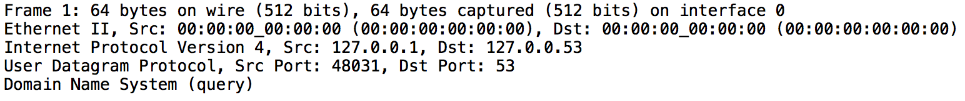

The image above shows the order of the top-level protocol. As you can see from the image, the top-level protocol is the DNS, followed by the UDP, followed by IPV4, followed by Ethernet II, followed by Frame I.

1. I could not capture any multicast message sent on my local network. For two protocols relying on multicasting, I found Resource Reservation Protocol, short is RSVPm and Real-time Transport Protocol, short is RTP. RSVP is designed to serve different resources across a network of Quality of Service, short is QoS, by using the model of internet integrated services. RTP is a data transfer protocol designed to exchange real-time sensitive audio-visual data on IP-based networks.
2. Since luther.edu is currently https, I am going to look at http://hackisu.org/

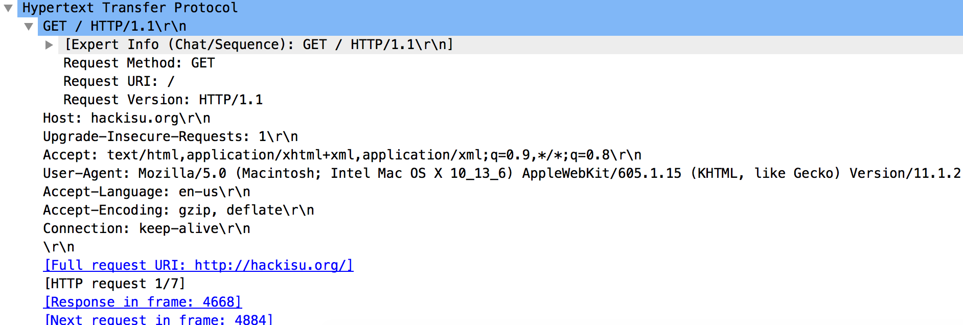

This is the first HTTP GET request, out of seven other requests, to download the web page of hackisu.org. This GET request specifies the accepted language, encoding, and the browser we are using besides the OS of this device making the request.



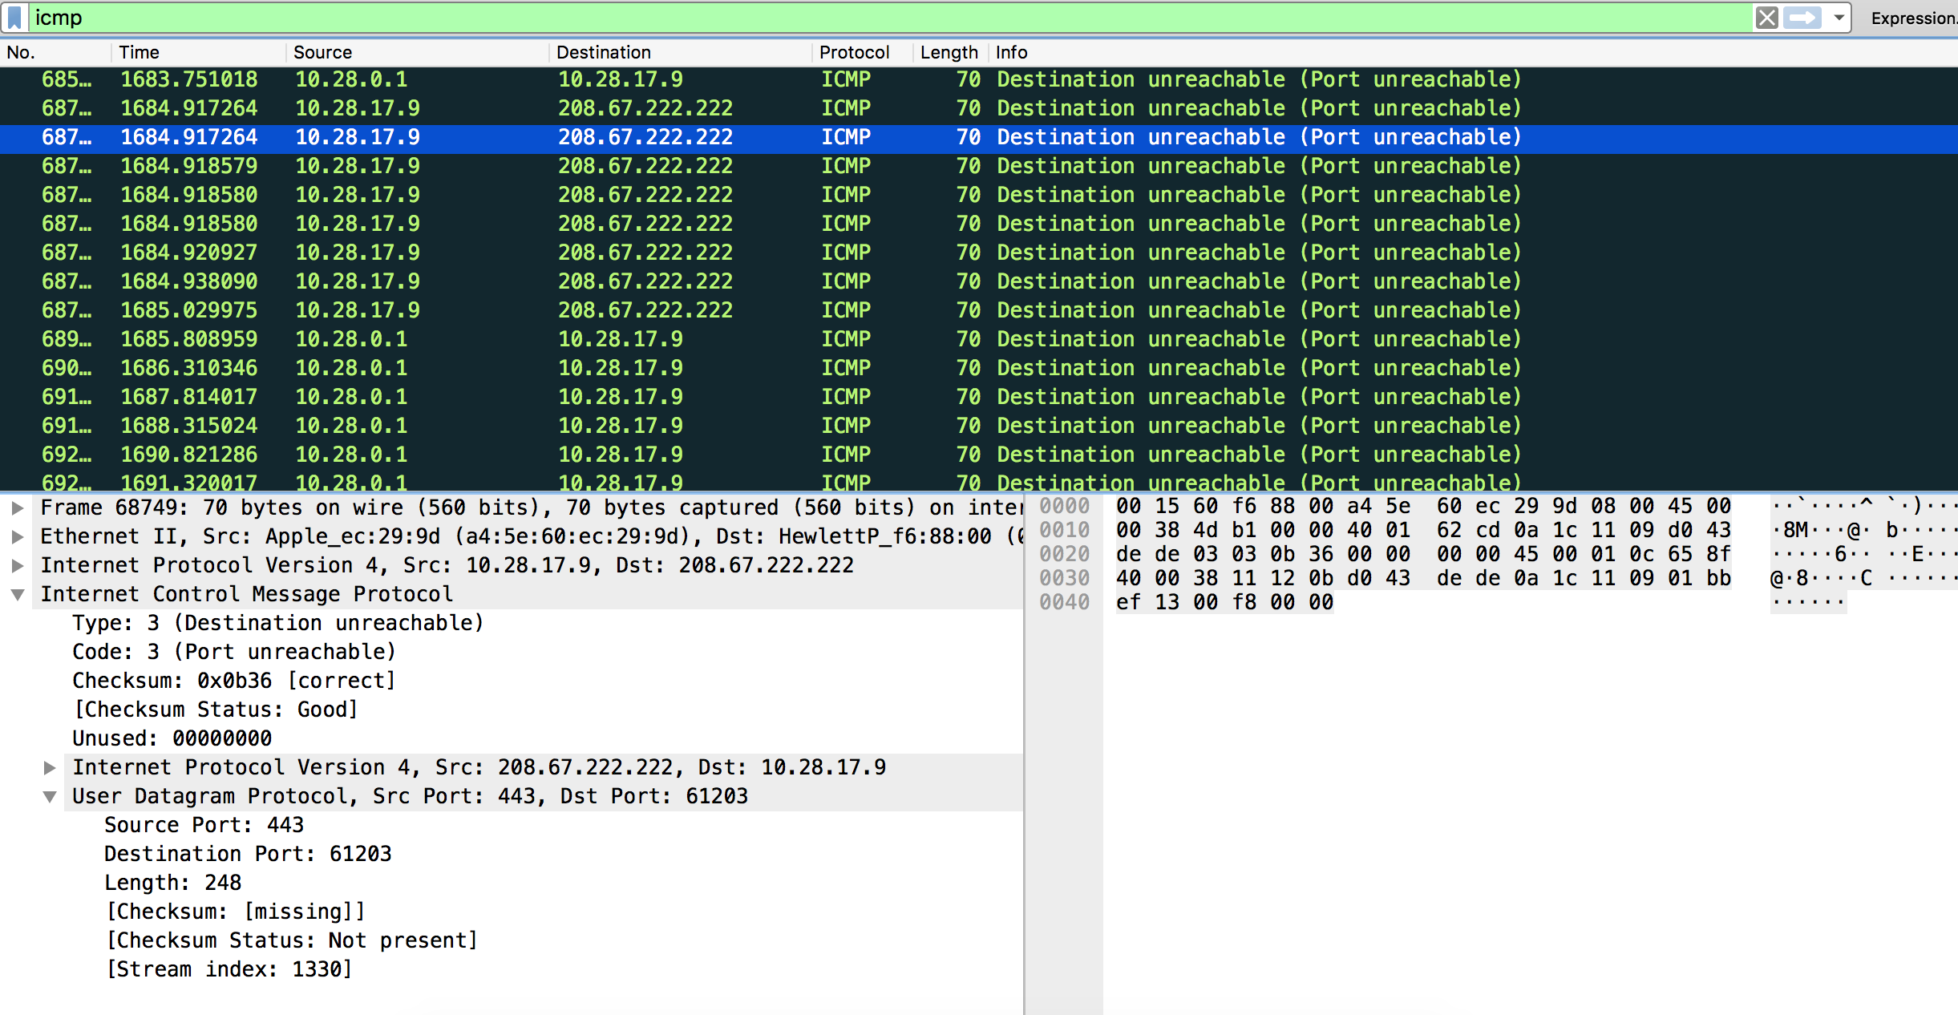

According to this [article](http://www.informit.com/articles/article.aspx?p=26557&seqNum=5), there are 19 types of ICMP Message Types, which are: Echo Reply, Destination Unreachable, Source Quench, Redirect, Echo Request, Router Advertisement, Router Solicitation, Time Exceeded, Parameter Problem, Timestamp Request, Timestamp Reply, Information Request (obsolete), Information Reply (obsolete), Address Mask Request, Address Mask Reply.